Before creating a page using editable template, enable it to make use of this template.

Steps:

1. Go to template that was created.
2. Click on the dotted icon on right side and select **“Enable”.**

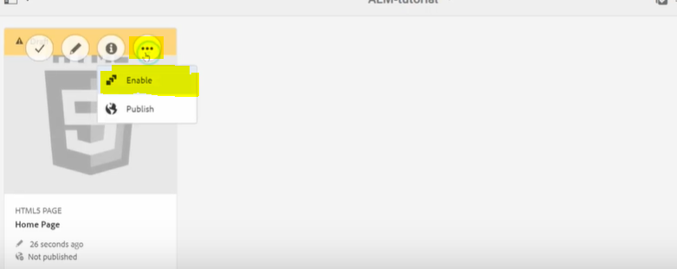

1. Click on enable after a popup prompt.

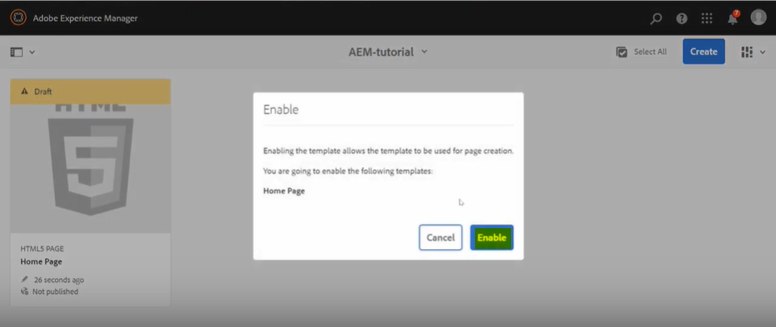

Now the template will be available for page creation.

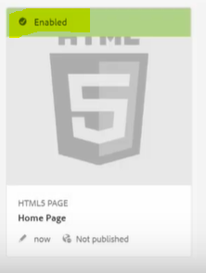

Creating a Page using Editable Template in AEM.

**Steps:**

1. Go to the sites console, and in the homepage-english page, click on create.

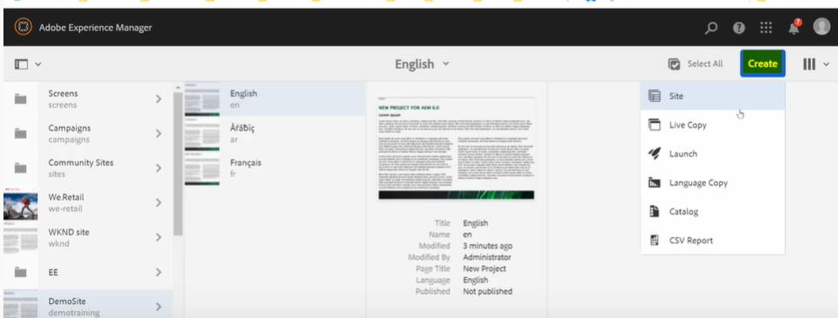

There is no create page option yet. We need to configure the allowed editable template path value at this level to allow creation of pages under this English page.

1. Select the English page and click on properties. In the advanced section you will find the option of allowed templates.

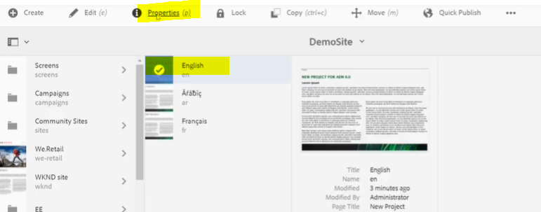

1. Under Advanced tab, go to Templates settings section and add the editable templates value.

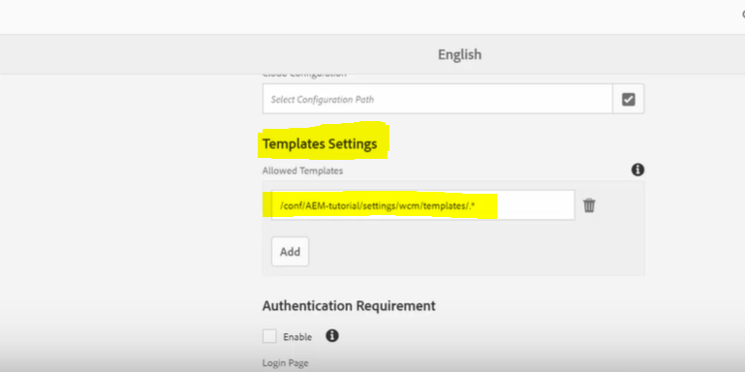

1. Click on Save & close button to save these changes.
2. Go back to English root page, and now we should be able to see the create page option as we have added allowed templates value.

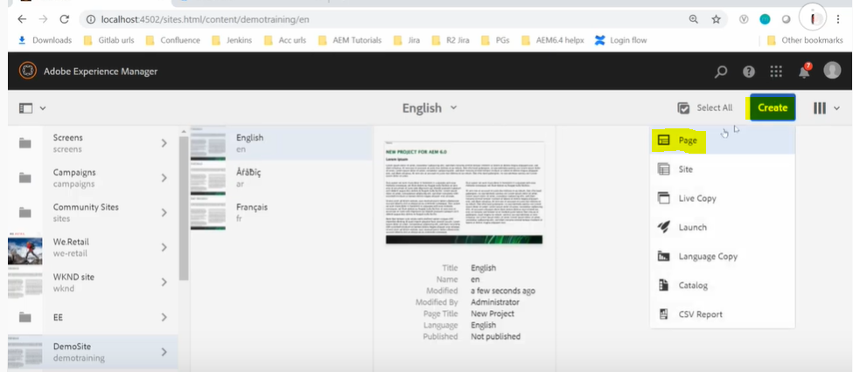

1. Now after clicking on create -> Page -> Select the Home Page template -> Next -> Provide the page details. After successfully creating the page, it should look like the below mentioned screen capture.

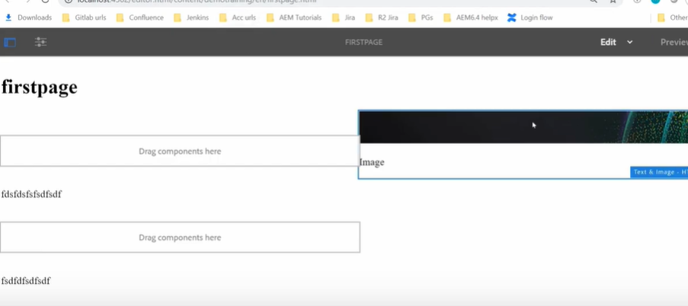

**Verification of policies created**

As we have created policies in our earlier steps, to verify those changes we can do the following.

1. When content author tries to add the component in first layout container, there should be only video component available.

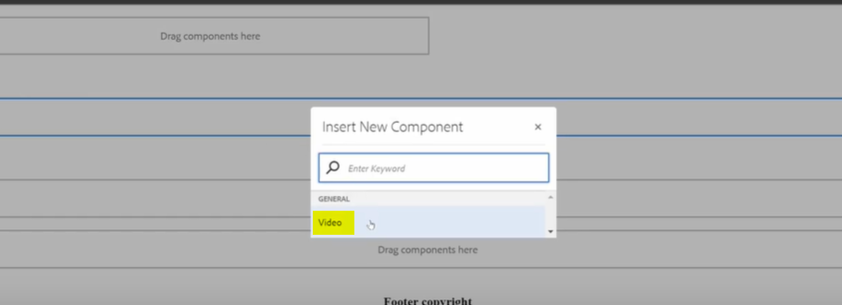

1. For the second layout container, there should be image related components available to add.

